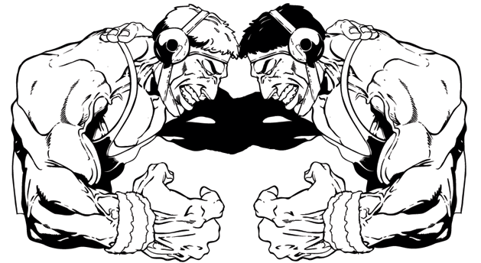MCj03982550000[1]

**See our website for more information at: bcthunderwrestling.weebly.com/**

BUHACH COLONY HIGH SCHOOL

1800 BUHACH ROAD

ATWATER, CA 95301

BUHACH COLONY THUNDER YOUTH WRESTLING CLUB

INTRODUCING:

Gabe Felix

Coach Osmer

201-9400

eosmer@muhsd.org

**SIGN UPS AND PRACTICE START NOVEMBER 3, 2016 FROM 5:30-7pm OR AT ANY PRACTICE IN THE BCHS WRESTLING ROOM.**

* **PRACTICES: TUESDAYS & THURSDAYS—STARTING NOVEMBER 3, 2016**
* **5:30 to 7:00 pm**
* **IN THE BUHACH COLONY WRESLTING ROOM LOCATED IN BACK OF THE SCHOOL NEXT TO THE WEIGHT ROOM BY THE POOL.**
* **$40 CLUB DUES (checks can be made out to Thunder wrestling)**
* **IN ORDER TO PRACTICE YOU MUST PURCHASE THE USA WRESTLING CARD AT: ca-usaw.org (Go to membership/Athlete and follow the directions on that page. Register Under San Joaquin Wrestling Association) The cost is $40.00, WHICH INCLUDES: MEMBERSHIP, INSURANCE, AND USA WRESTLING NEWSLETTERS**
* **MORE INFORMATION AT SIGN UPS**
* **USAW FOLKSTYLE SCHEDULE WILL BE HANDED OUT AT PRACTICE**

A MAN CAN FAIL MANY TIMES BUT, HE IS NOT A FAILURE UNTIL HE GIVES UP

OUR COACHES WILL BE TEACHING FOLKSTYLE, FREESTYLE WRESTLING BASICS AND FUNDAMENTALS. THE THUNDER WRESTLING CLUB IS WHERE CHAMPIONS ARE MADE AND OUR CHAMPIONSHIP TRADITION BEGINS. LOCAL USAW TOURNAMENT SCHEDULE WILL BE MADE AVAILIABLE AT PRACTICE. COACHES WILL BE AVAILABLE AT THE TOURNAMENTS.

**BUHACH COLONY THUNDER YOUTH**

**WRESTLING CLUB**